Hotel Booking Analysis
Group Project Report

Team Members:
Katarina Vasic
Gino Canoy
Ruby Campana
Computer Applications - Data Processing with Python
October 2026

Table of Contents
1 Purpose and research questions 1
2 Data preparation and used methods 1
3 Main findings 2
4 Special requests and other patterns 3
5 Limitations 3
6 Conclusion and recommendation 4

Purpose and research questions
This report looks at booking patterns at City Hotel and Resort Hotel, focusing on cancellations, length of stay and daily rates. Our aim was to understand how bookings differed between the two hotels and whether special requests were linked to cancellations.
We used a dataset of 1,000 bookings and 20 variables, covering planned arrivals from July 2015 to August 2017. Each row represents one booking, whether cancelled or not. The original data came from hotels in Lisbon and the Algarve, Portugal. These types of reports can help hotels with revenue forecasting and help answer these research questions:
1. Do cancellation rates differ between City Hotel and Resort Hotel?
2. How do length of a stay and an average daily rate differ between the two hotel types?
3. Is the number of special requests associated with cancellation?

Data preparation and used methods
We used Python and Pandas to check for missing information, duplicate rows, incorrect dates and unusual values. We worked on a copy, so the original data stayed unchanged. After removing 26 duplicate rows and three bookings with no guests, 971 bookings remained. Two missing country values were labelled “Unknown.”
We kept two bookings with zero nights but marked their stay lengths as missing. We also marked zero daily rates as missing, leaving 959 bookings with positive rates for the price analysis. We kept high prices and long lead times because they could be valid bookings. All cleaning decisions were explained in a cleaning log.
We added columns for arrival date, total nights, total guests and estimated booking value. Booking value was calculated by multiplying the daily rate by the number of nights. This is only an estimate, since cancelled bookings may not generate that income.
We then used tables, summary statistics and charts to describe the bookings and compare groups. Missing values were left out only from calculations that needed them. For percentage comparisons, we used the total within each group—for example, cancellations at City Hotel were divided by all valid City Hotel bookings.

Main findings
Overall, 346 of the 971 cleaned bookings were cancelled (35.63%). City Hotel had 261 cancellations out of 615 bookings (42.44%), compared with 85 out of 356 (23.88%) at Resort Hotel. The difference was 18.56 percentage points.
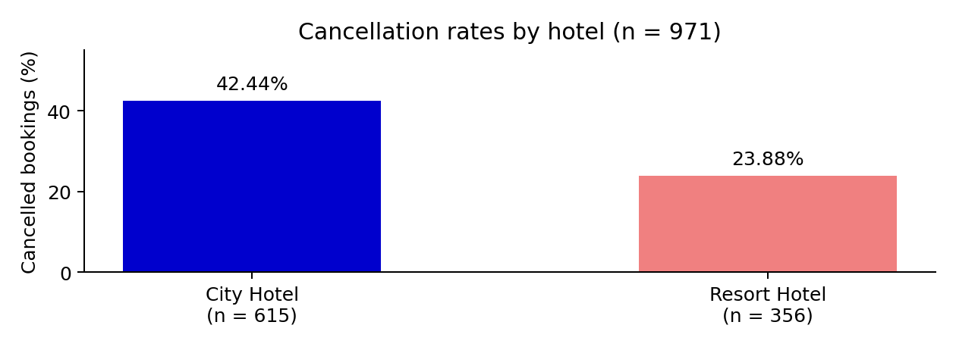
Figure 1. Percentages use the number of cleaned bookings within each hotel as the denominator.
Resort Hotel bookings had longer planned stays. City Hotel had higher positive recorded daily rates. The means and medians agreed on both patterns, although Resort Hotel had more variation in stay length and price.
Measure | City Hotel | Resort Hotel
Valid stay lengths | 614 | 355
Average nights | 3.05 | 4.24
Median nights | 3 | 4
Valid positive daily rates | 608 | 351
Average daily rate | 107.83 | 94.73
Median daily rate | 101.25 | 78.60
Across both hotels, the average planned stay was 3.49 nights, with a median of 3 and a range of 1 to 28 nights (n = 969). The average positive daily rate was 103.03, with a median of 95 and a range of 6 to 304 (n = 959). Both distributions were right-skewed: a few large values pulled their averages above their medians.

Special requests and other patterns
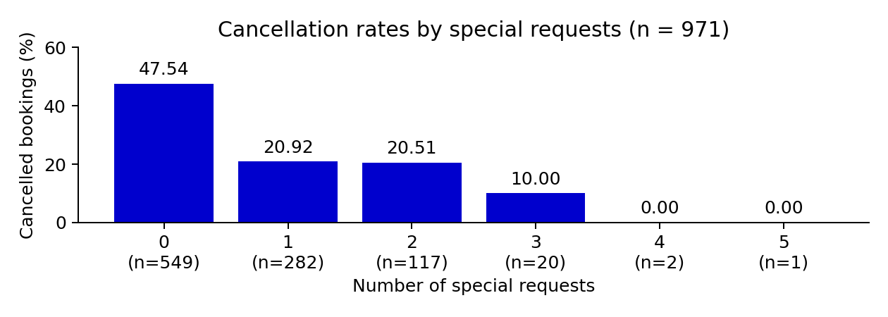
Figure 2. Each percentage uses bookings within that request category as its denominator. Categories with four or five requests contain very few bookings.
Bookings with special requests had lower cancellation rates. For bookings with no requests, 47.54% were cancelled. This dropped to 20.92% for one request, 20.51% for two requests and 10% for three requests. None of the bookings with four or five requests were ever cancelled, but there were only three bookings in these two groups, so we cannot draw a strong conclusion based on them.
Cancelled bookings were made an average of 139.87 days before arrival, compared with 82.75 days for bookings that were not cancelled. The median was also higher: 113 days compared with 48 days.
May 2017 had the most bookings in our cleaned sample, with 41 at City Hotel and 24 at Resort Hotel. These numbers include cancelled bookings, so they do not show how many guests actually stayed.

Limitations
This is an old sample from two hotels, before Covid-19 time, so the results may not apply to other hotels or current demand. The comparisons do not account for other factors, such as season or market segment, and cannot establish what causes cancellation.
Cleaning choices may change the findings. Without a booking identifier, matching rows could be separate bookings rather than duplicate records. Zero daily rates may represent complimentary stays, so excluding them limits the pricing results to positive rates. Cancelled bookings remain in the analysis; planned nights and estimated values are not actual stays or revenue.

Conclusion and recommendation
The three research questions show a consistent picture: City Hotel had more cancellations and higher rates, Resort Hotel had longer planned stays, and special requests were associated with fewer cancellations. We recommend monitoring cancellations by hotel and lead time, and testing pre-arrival confirmations for City Hotel bookings made far in advance. The effect of that trial should be measured before wider use.
A useful next question is why guests cancel and whether their reasons differ between hotels. The supplied variables do not include cancellation reasons.
Data source: Course sample of António, N., de Almeida, A., and Nunes, L. (2019). Hotel booking demand datasets. Data in Brief, 22, 41–49. https://doi.org/10.1016/j.dib.2018.11.126

